
Name = Muhammad Daniyal
Registration no = 24371
Submitted to : Mam Faryal

Software Construction and Development CA

Lab 10

Task 1:
- Create a Rectangle class
  - Add variables: length, width
  - Add constructor
  - Add area() method

Create an object
  - Make an object of Rectangle
  - Use it to call the area() method

Input/output:
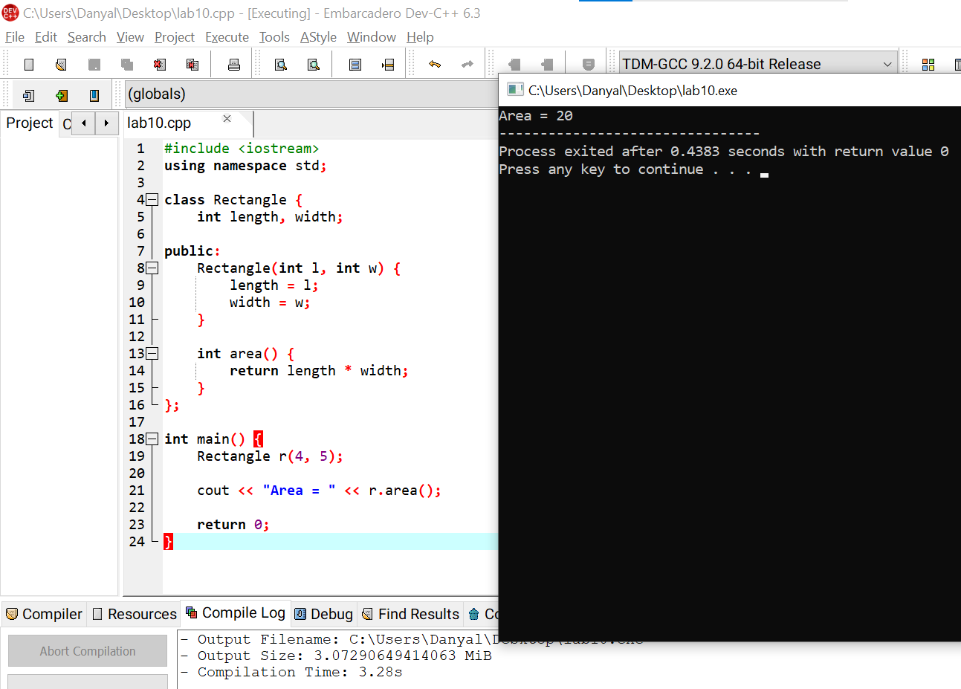

Task 2:
Add a new method to calculate the perimeter of the rectangle.

Hint:
Perimeter = 2 * (length + width)
Print the perimeter in the main() function.
Input/output:
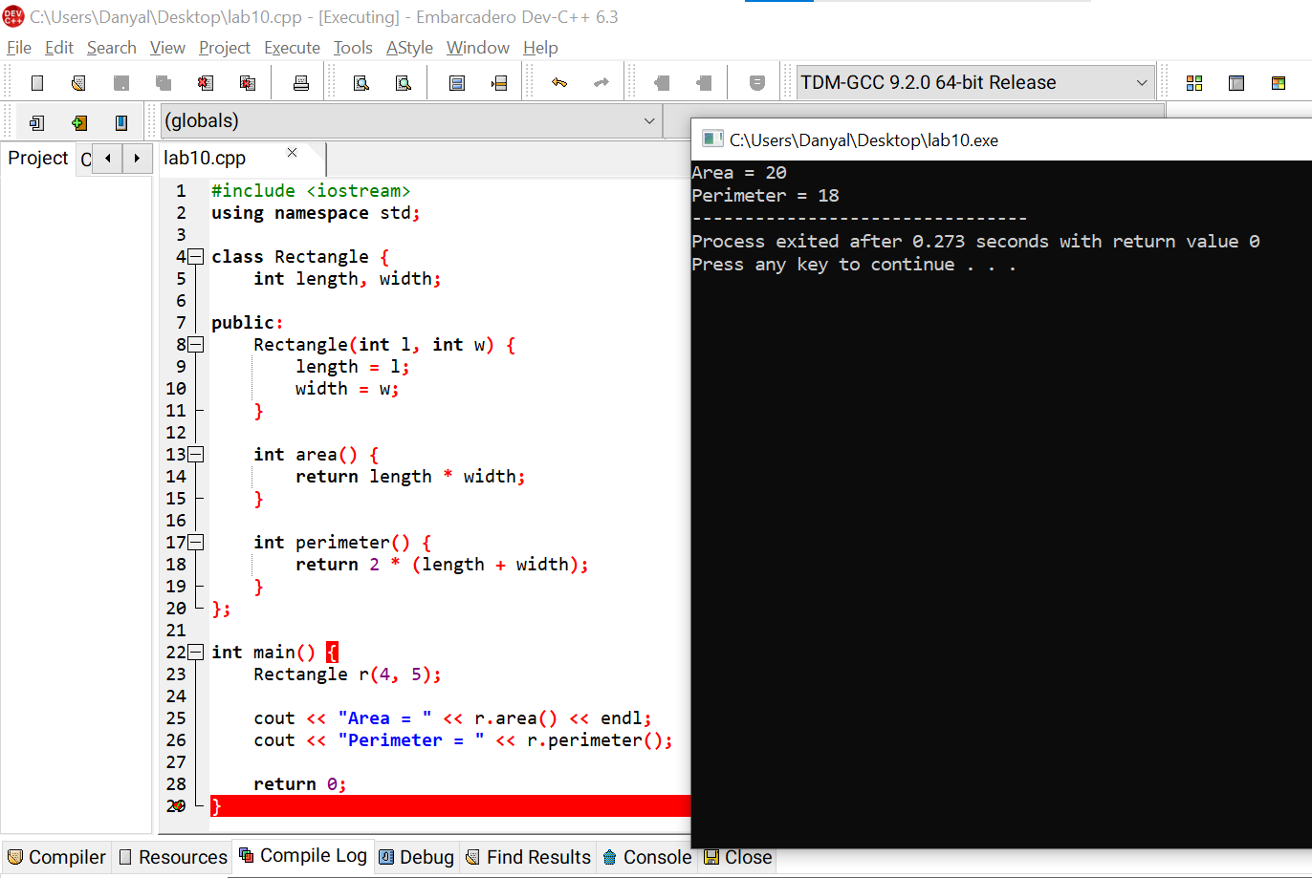

Task 3:
Create three rectangle objects with different values and display their area and perimeter.
Input/output:
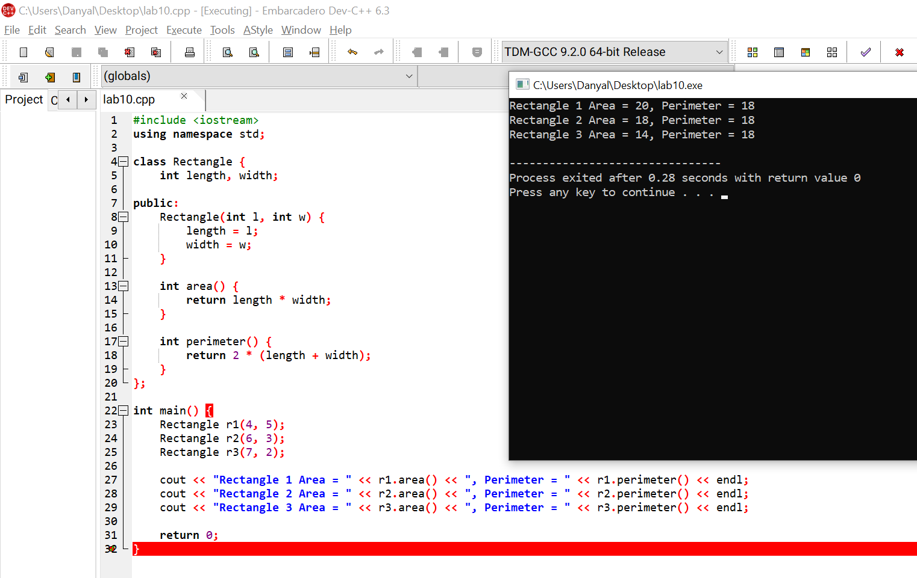

Task 4:
Modify the program so the user enters the length and width. Hint: Use cin >> length; and cin >> width;
Input/output:
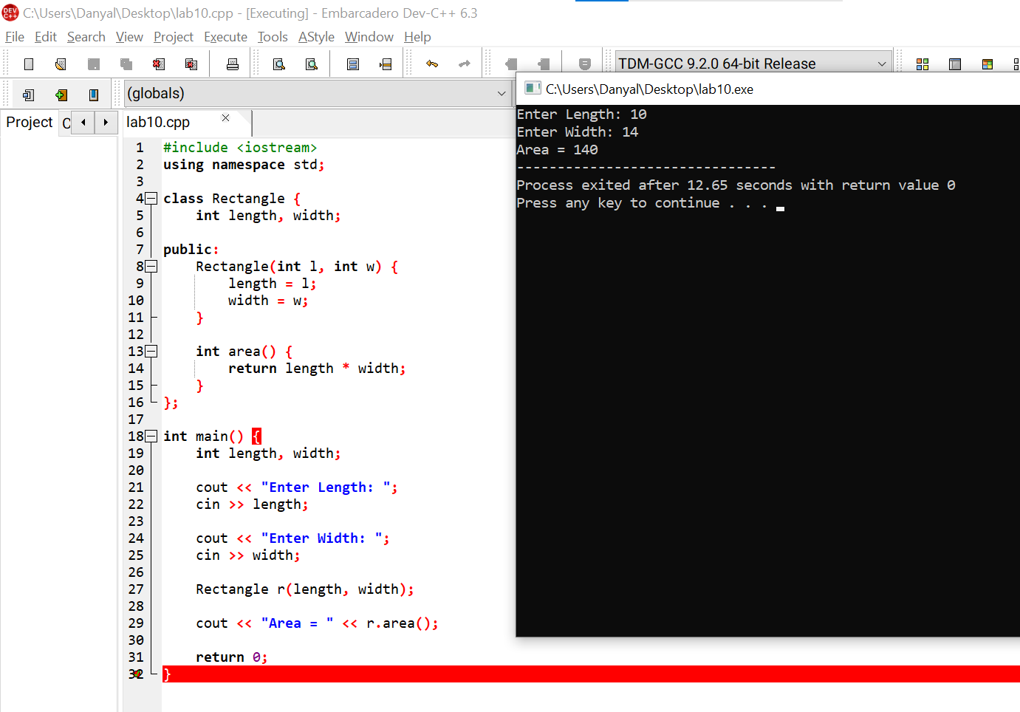

Task 5:
Create a new class called Square with:
- one variable: side
- a constructor
- an area() method
Make an object and print the area.
Input/outut:
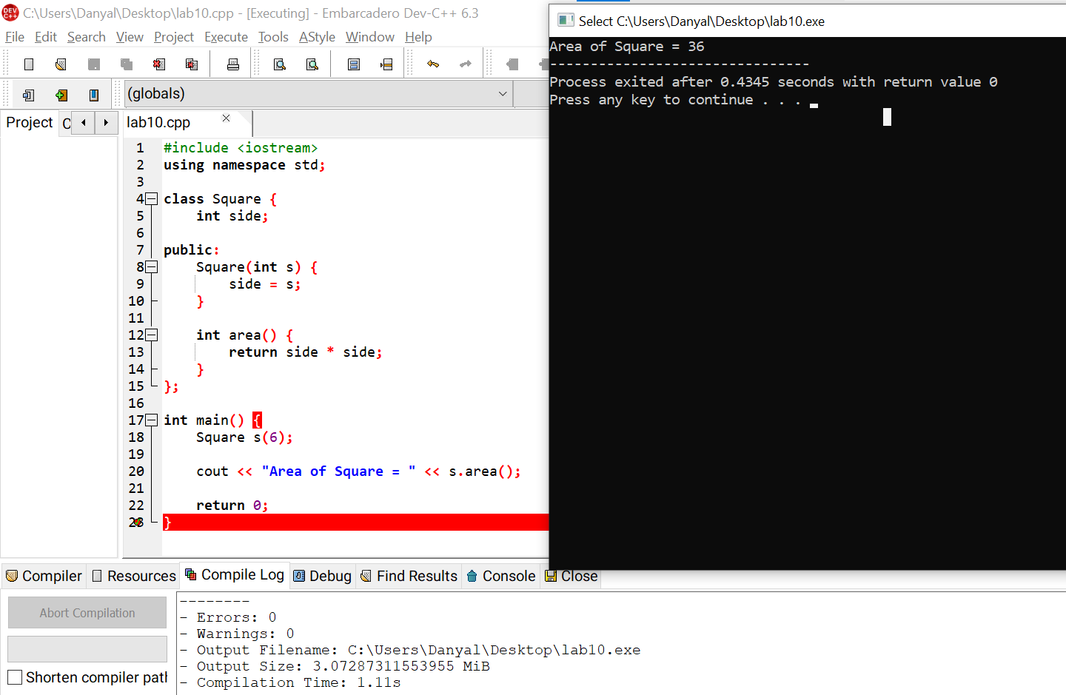

Task 6:
Write a program that creates two rectangle objects and prints which one has a bigger area.
Input/output:
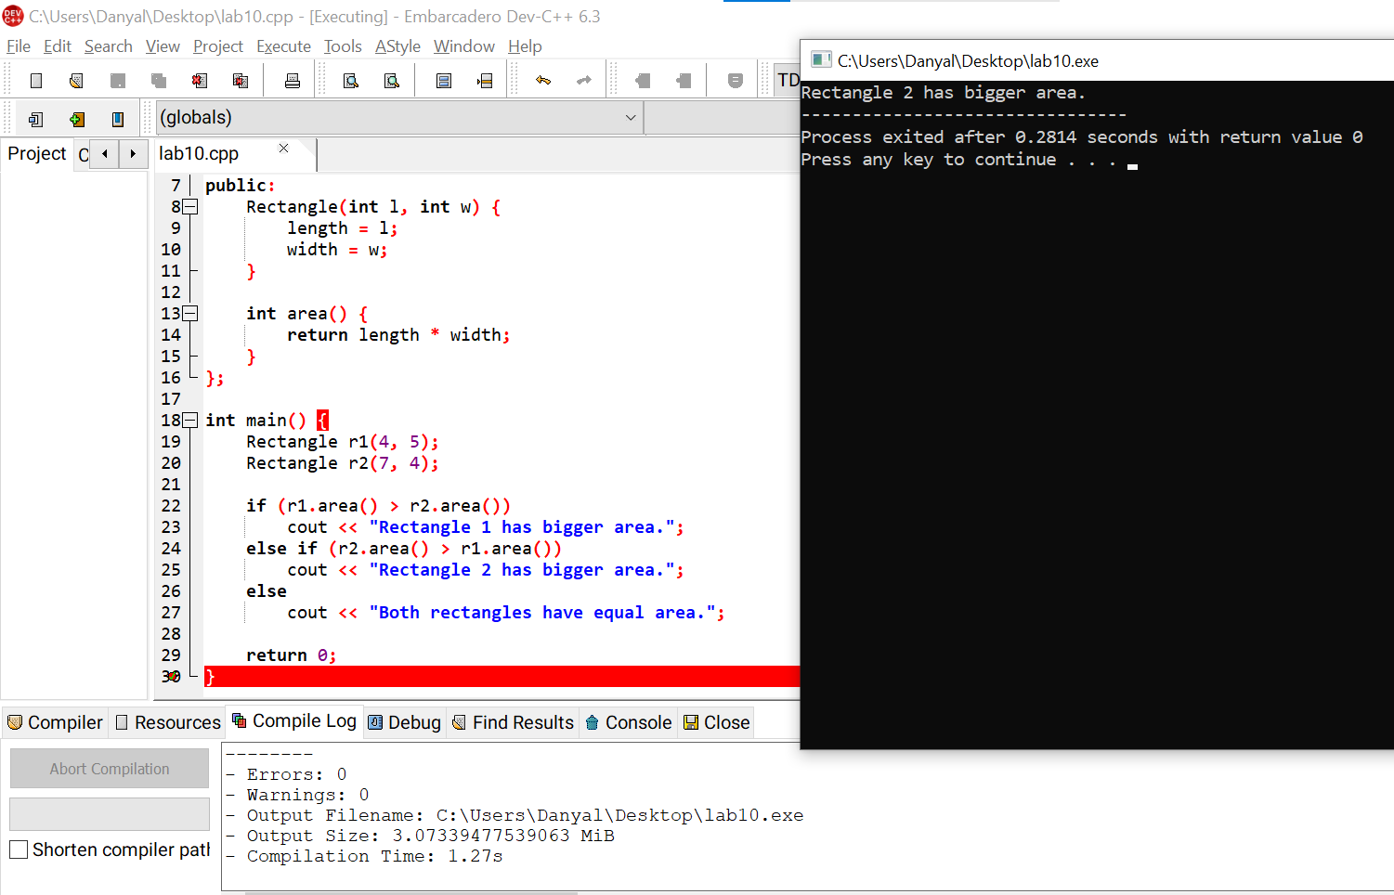

Task 7:
Create a class Student that contains:
- Name
- Roll Number
- Marks

Create an object and display the student details.
Input/output:
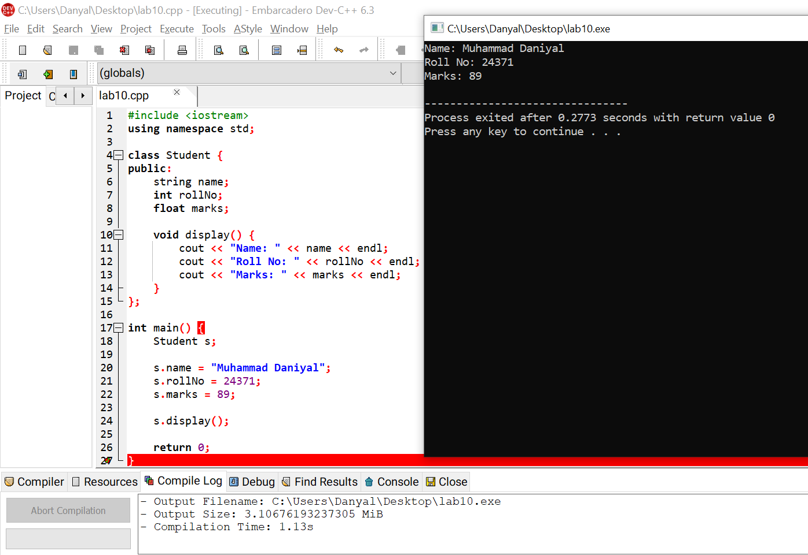

Task 8:
Create a class Rectangle that:
- Takes length and width
- Calculates and displays the area.
Input/output:
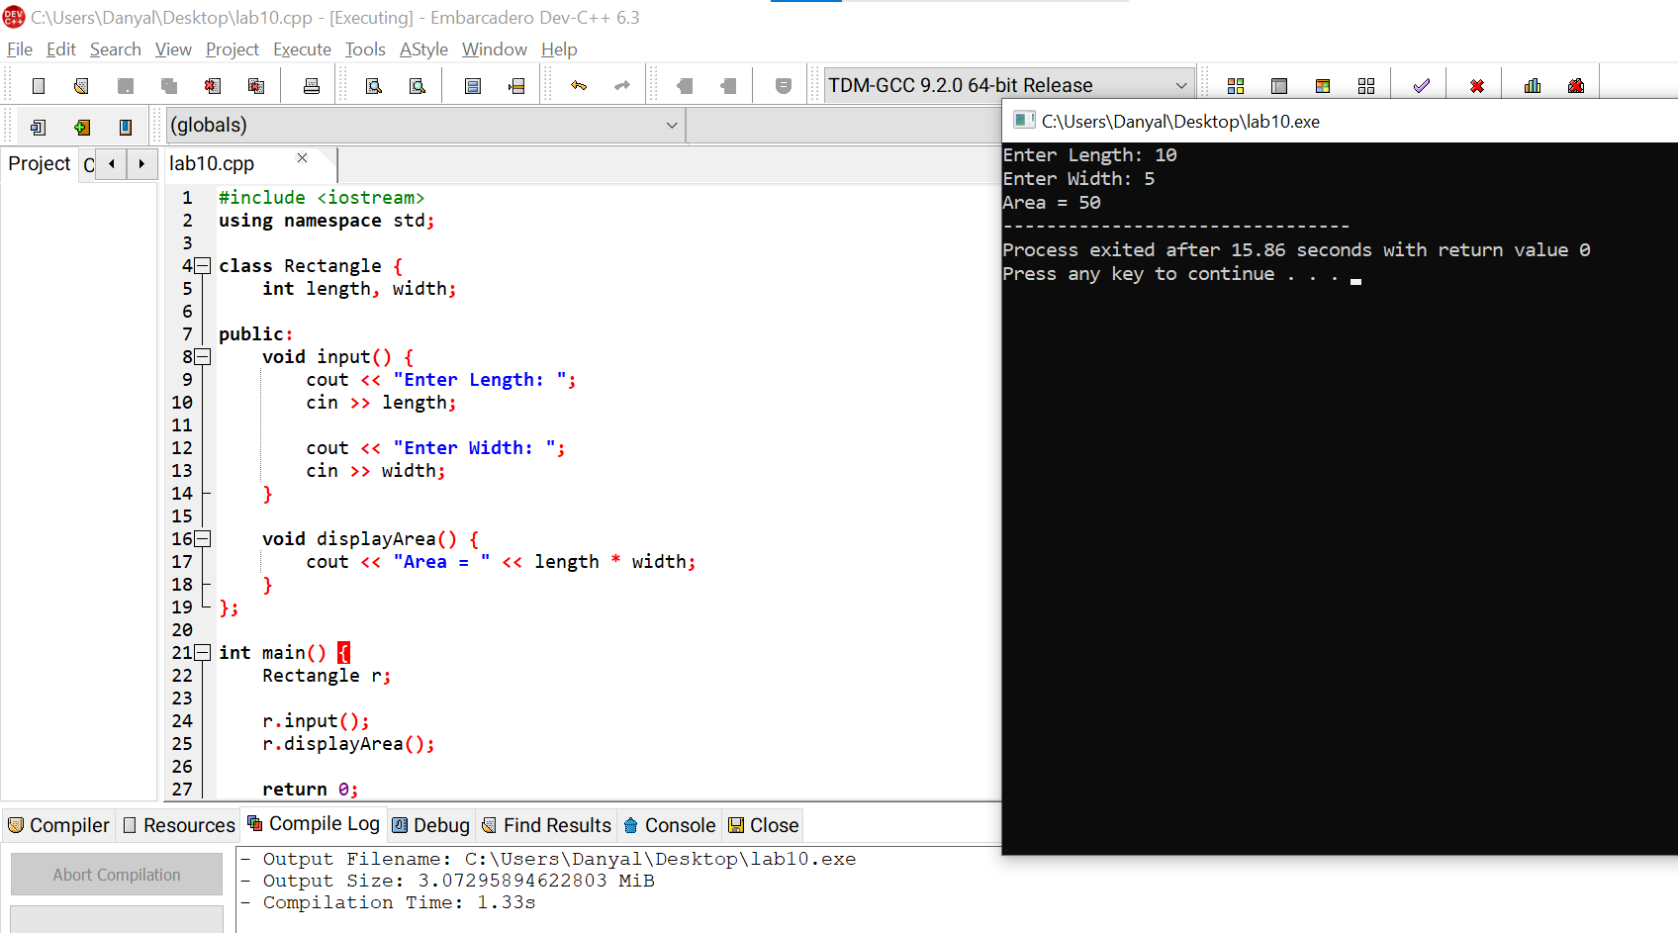

Task 9:
Create a class Car that stores:
- Brand
- Model
- Year
Display the details using a member function.
Input/output:
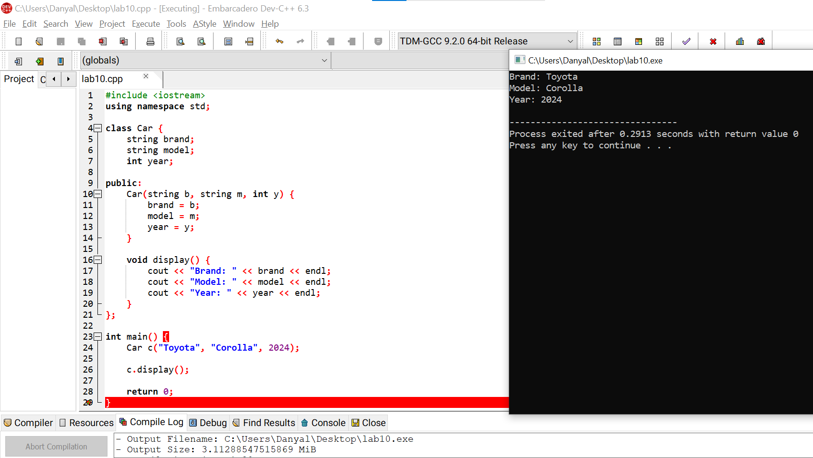

Task 10:
Write a class Calculator that performs:
- Addition
- Subtraction using member functions.
Input/output:
